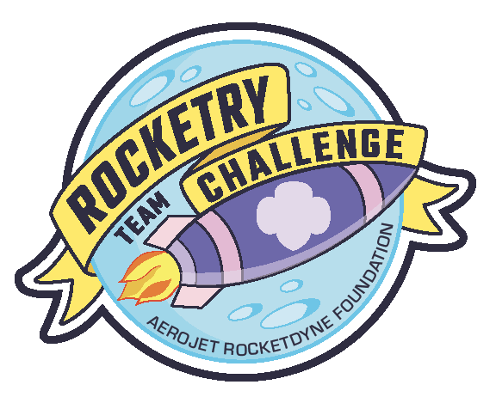



Come fly with us!

Are you interested in STEM? Would you like to learn to build and fly rockets?

Girl Scout Troop [Troop #] is forming a sport rocketry team and we want YOU!

Rocketry is a fun way to learn about science, technology, engineering, and math concepts like the physics of flight, aerospace engineering, computer flight simulation, and model rocket design.

We’ll work together to learn about rocketry and then design, build, and test our rocket. We’ll build our teamwork and leadership skills, too!

Contact Girl Scout Troop [Troop #] for more information.





Phone: [Phone #]

Email: [Email Address]

